**PEDESTRIAN CROSSING**

**WIRING DIAGRAM**

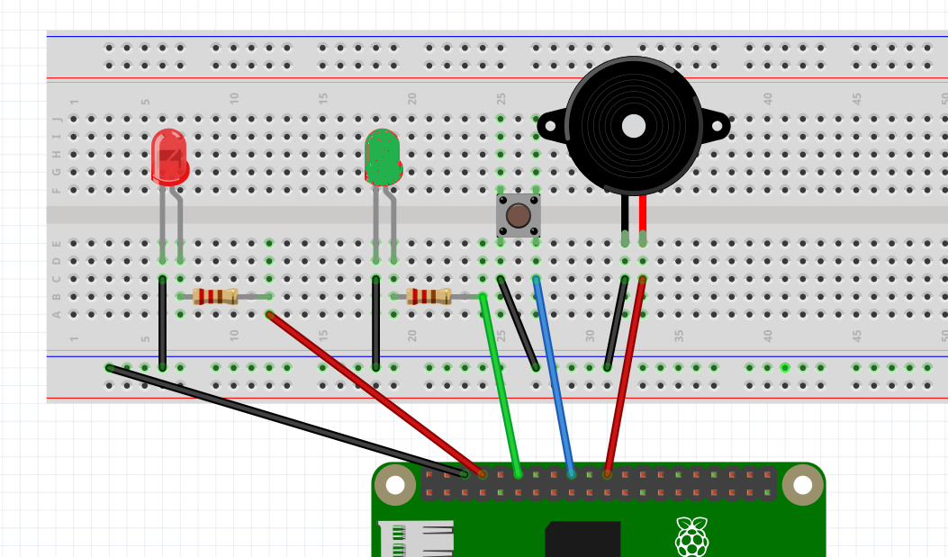

THIS IS HOW A PEDESTRIAN CROSSING WORKS.

1. RED LIGHT ON
2. WAIT FOR BUTTON TO BE PRESSED
3. WHEN BUTTON IS PRESSED
4. WAIT 10 SECONDS
5. RED LIGHT GOES OFF, GREEN LIGHT COMES ON
6. BUZZER BUZZ SLOWLY
7. ALLOW 15 SECONDS FOR PEDESTRIANS TO CROSS
8. BUZZER BUZZ FASTER, SIGNIFYING THAT TIME IS COMING UP
9. GIVE 5 SECONDS GRACE PERIOD
10. GREEN LIGHT GOES OFF, RED LIGHT COMES ON

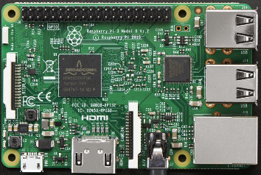

**ORIENTATION OF RASPBERRY PI >>>**

**PIN 25**

**PIN 14**

**PIN 24**

**PIN 18**

**GROUND**

**-VE**

**+VE**

**BUTTON**

**GROUND**

**PIN 18**

**PIN 23**

**+**